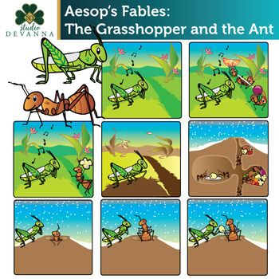Once upon the time in the summer season have the little grasshopper that walked and jump on the grass look really happy in it life, it’s sing the song and see the view nature with the green grass and beautiful flower, and it was a good day for grasshopper. A valve later grasshopper continue walked and jump with his happies and sing and then he met the herb of the ants they look really busy with their work, they walk by the line and carry the food by careful and then the grasshopper called the ant to asked why they do like that? The grasshopper asked to the ant why you try to work hard? And why don’t you enjoy with the beautiful day? And then the little ant reply to the grasshopper we can’t spend their own time with doing something for funny but we are trying to find the food for the nearly winter season because it nearly come and then the ant ask to the grasshopper do you have the food for the winter. The grasshopper don’t care about the world that ant say and continue to sing the song and the hole of ants continue to collect the food into their hole that can keep their food from the water.

A few days have passed the winter season has arrived it was a very cold season that all animal can’t get out of their place. All the ants that collect the food they stay in their own hole and they don’t worry about the food because they already find it in the last summer yet. But take a look to the grasshopper that the last summer he busy with sing and dance now he doesn’t have anything to eat and the weather cold and cold the grasshopper try to walk and find something to eat on the show. But suddenly he walk pass the hole of the ant and immediately grasshopper see the little ant that used to talk with him last summer. The ant noted that he use to know this animal or insect. And they talk with each other for while and then the ant go to their hole and get their food for his friend grasshopper for eat and our story will be end the meaning of this story is ant is the animal that solidarity in working and they think about their future not for only today. Like our study, Do not be happy in the present until you forget about your future.

The END.